 | Beit HaYeladim Preschool at Congregation B’nai B’rith  Financial Aid Application 2018-19 | 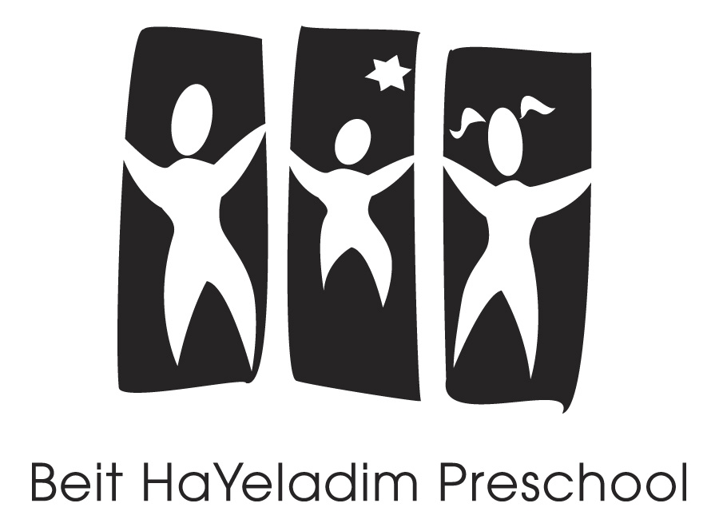

Financial Aid Guidelines:
- Applicants must submit this completed Financial Aid Application along with a completed BHY Registration Form in order for CBB to review your request.

- Applicants must be members in good standing at Congregation B’nai Birth. Exceptions must be reviewed with the Executive Director.

- Financial aid requests must be “last resort” funds, after supplementing assistance provided by family and all other possible resources.

- Financial aid is awarded for tuition only, ranging from 5% - 25%. (Financial aid is not applied to lunches, registration fees or graduation fees.)

- If the student’s schedule changes, your financial aid will be reviewed and may be adjusted.

- If your student moves from the Toddler Program to the PS Program, your financial aid will be adjusted so that your monthly tuition amount remains the same.

- After financial aid is granted, applicants must set up automatic monthly tuition payments on a debit/credit card and your account must be kept current in order to maintain your financial aid status.

Family Name(s) | Home Phone:
Parent/Guardian 1: | Parent/Guardian 2:
Cell Phone: | Cell Phone:
E-mail: | E-mail:
Occupation: | Occupation:
Employer: | Employer:
Please indicate your preferred contact and method (Parent 1 or 2 and Home Phone/Cell/Email) (circle one above)

*For different schedules in July and August vs. in September, please
complete two separate registration forms and indicate the different
tuition costs for each start date below.
*Start date: |  |  | *Start date: |  |  | Your Commitment to BHY & CBB
Child 1 monthly tuition cost: |  | $ | Child 1 monthly tuition cost: |  | $ | BHY tuition (including lunches, registration, or graduation fees): MONTHLY amount I can pay for the 17/18 school year:
Child 2 monthly tuition cost: |  | $ | Child 2 monthly tuition cost: |  | $ |  | $
Child 3 monthly tuition cost: |  | $ | Child 3 monthly tuition cost: |  | $ | Membership/Bldg: MONTHLY amount I can pay for the 17/18 membership year: | $
Total Tuition (without lunches, registration or graduation fees): |  | $ | Total Tuition (without lunches, registration or graduation fees): |  | $ | TOTAL MONTHLY BHY TUITION & MEMBERSHIP I AM ABLE TO PAY:  (July 2017 – June 2018) | $

Page 2
Please describe the special circumstances that support your request for financial aid this year (unusual expenses, family circumstance, medical, etc.:

Please tell us why it is important to you that your child(ren) have a Jewish early childhood education:

AGREEMENT:

- I hereby certify that all of the information provided in this application is true and accurate.
- I understand that my ability to receive financial assistance is based on my financial need and is available thanks to the generosity of Congregation B’nai B’rith members who pledge more than standard membership contributions as well as those who contribute to scholarship funds.
- I commit to pay more if I am able to at any point during the school year and to contribute back to the school in the future, if my finances allow.
- I agree to keep my financial arrangements with CBB strictly confidential. Any breach of confidentiality on my part will result in the immediate dissolution of this agreement.

_______________________________________________ _______________________________________________
Parent/Guardian 1 signature Date Parent/Guardian 2 signature Date

Submit this confidential application & reg. forms to: Elizabeth Gaynes, Executive Director or drop off in the BHY School office.
Please contact Elizabeth at 964-7869 x111 or Elizabeth@cbbsb.org with any questions or concerns.

For Committee Use:
Date Received: |  | Date Reviewed: | Date Notified:
Total Tuition (child 1): $ |  | Aid Granted: $ | Parent’s Monthly: Tuition | $
Total Tuition (child 2): $ |  | Aid Granted: $ | Lunches | $
Total Tuition (child 3): $ |  | Aid Granted: $ | Registration | $
 |  |  | Grad. Fee/Building Fund | $
 |  |  | MONTHLY PAYMENTS: | $

